Day 9 - 104608492 - Shirisha Perapagu

Exception Handling

Task 1 - ArrayIndexOutOfBoundsException demo

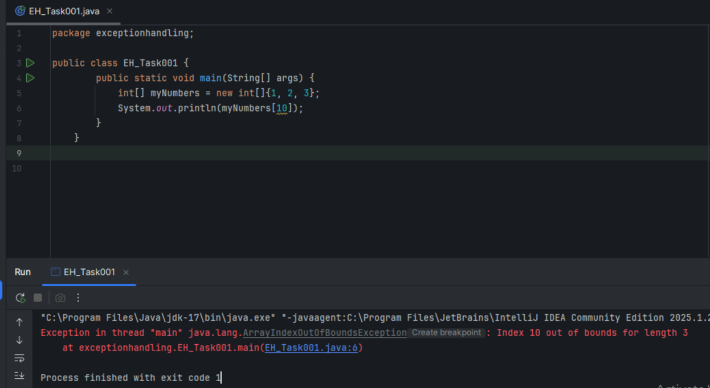

Task 2

try-catch block

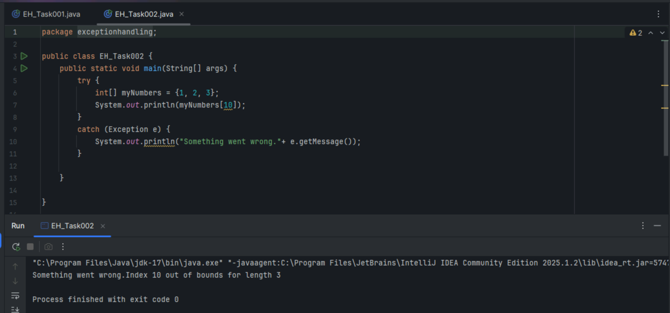

Task 3 – finally block with Exceptions

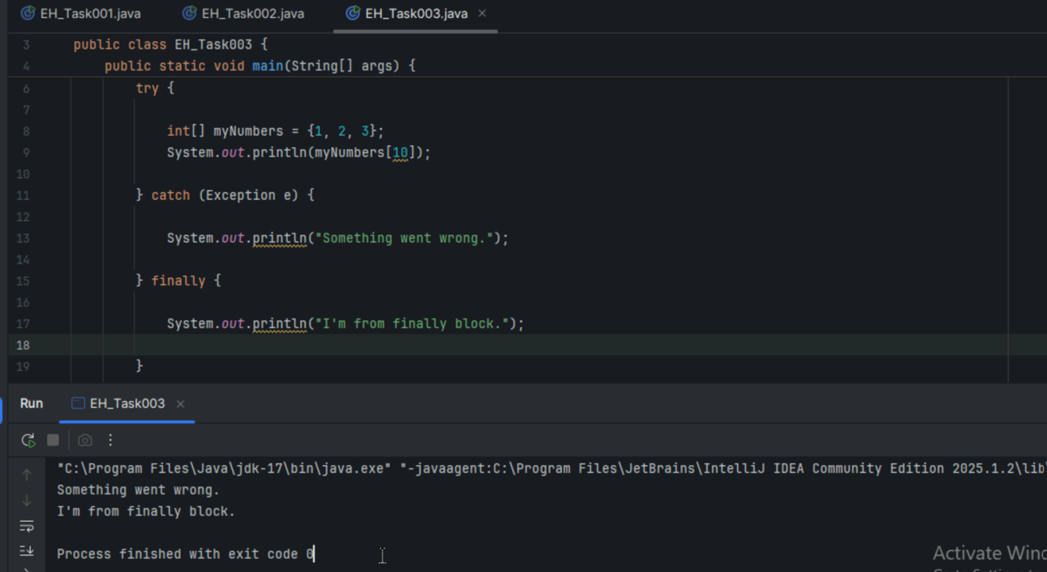

Task 4 – finally block without exceptions

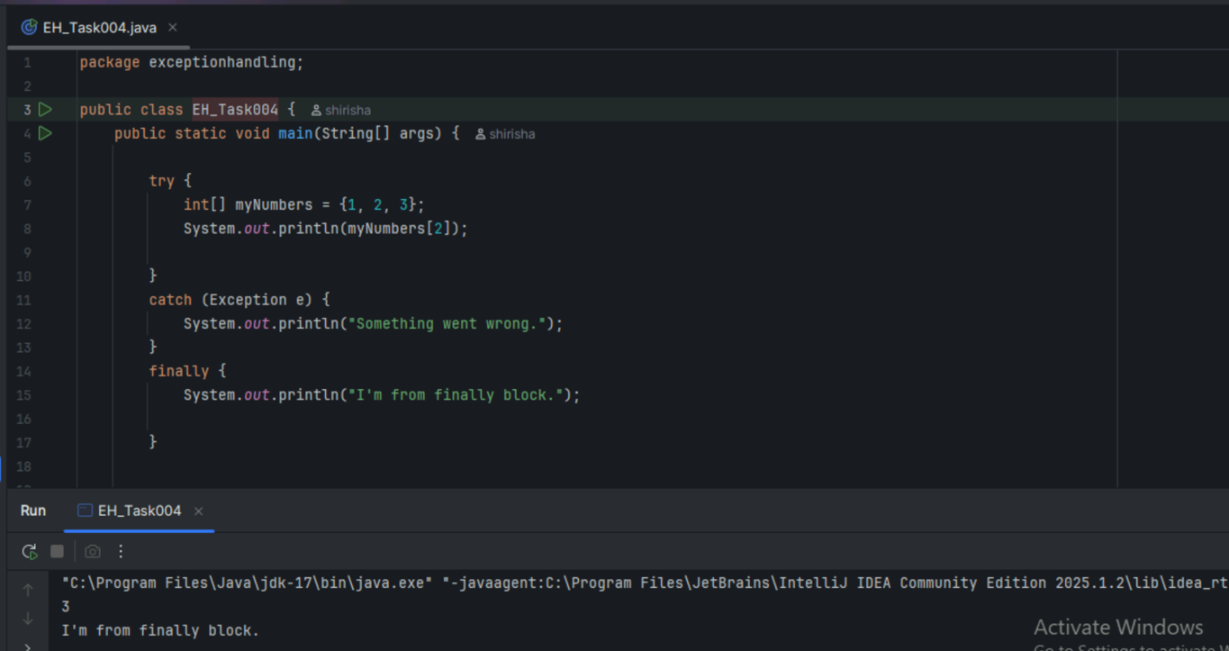

Task5 – Try multiple catch blocks.

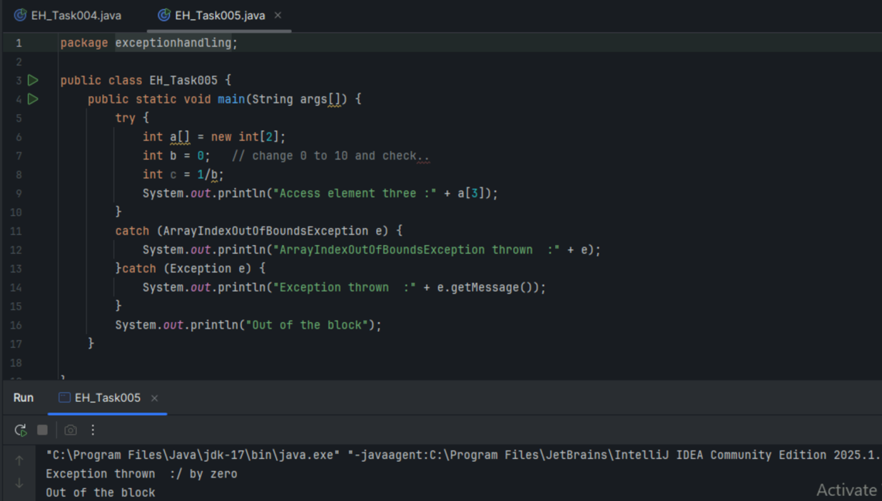

Task 6 – Nested try blocks

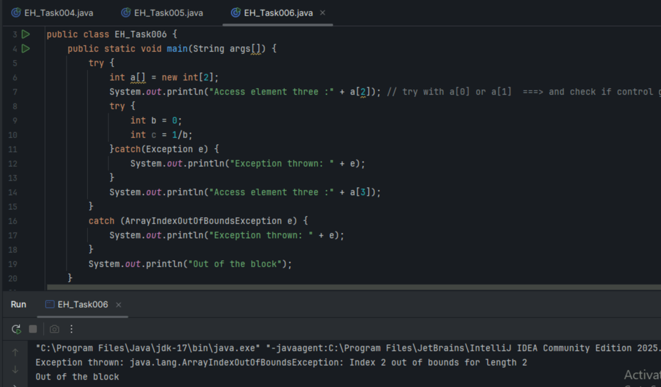

Task 7 – throw vs throws

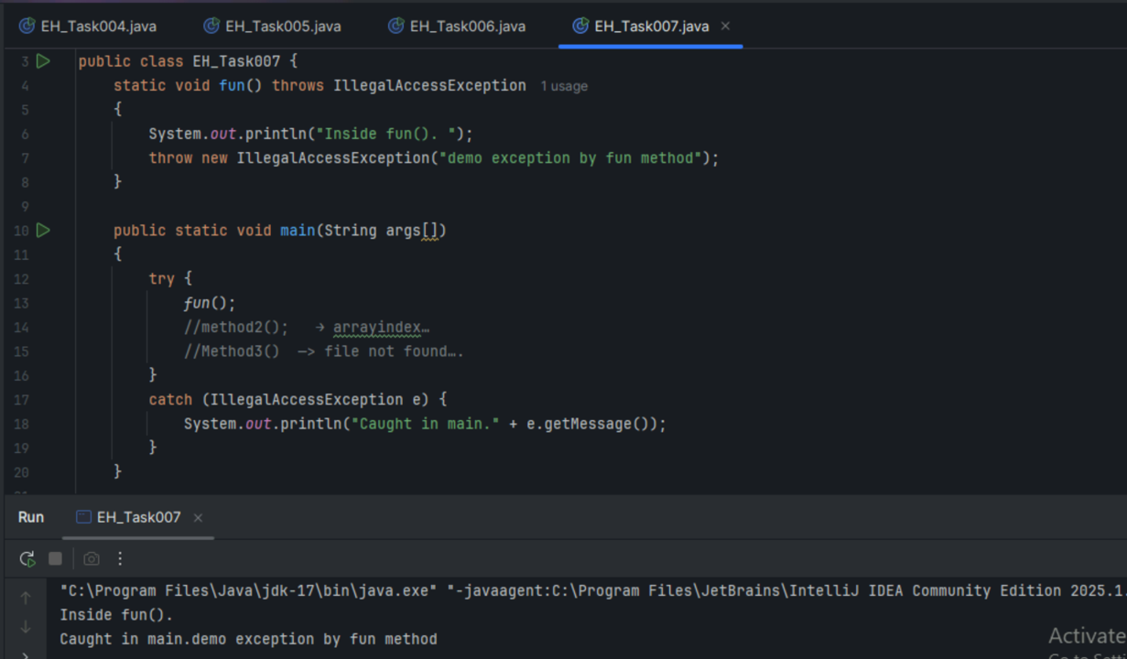

Task 8 Custom Exceptions

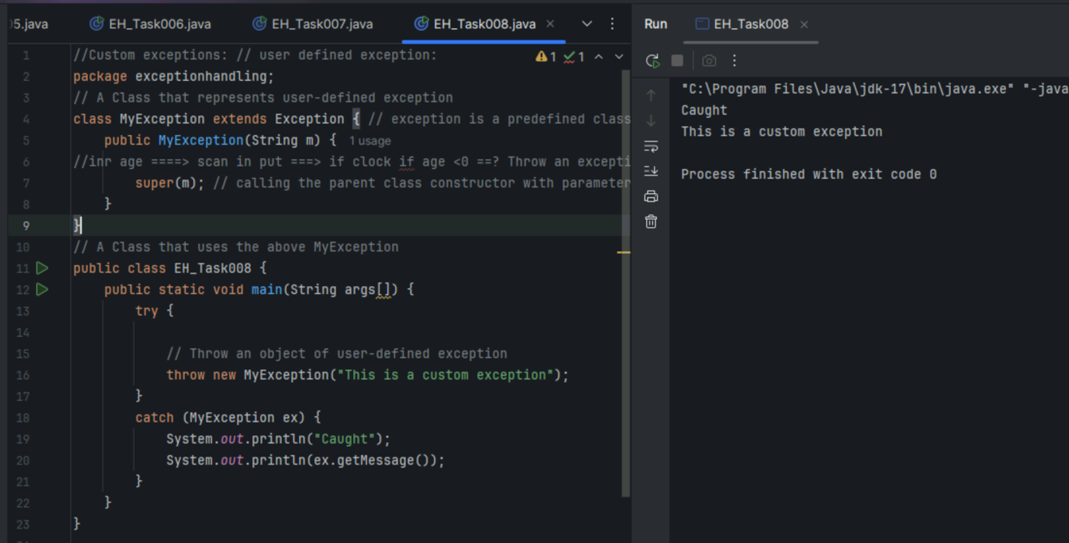

Task 9

ArrayList example

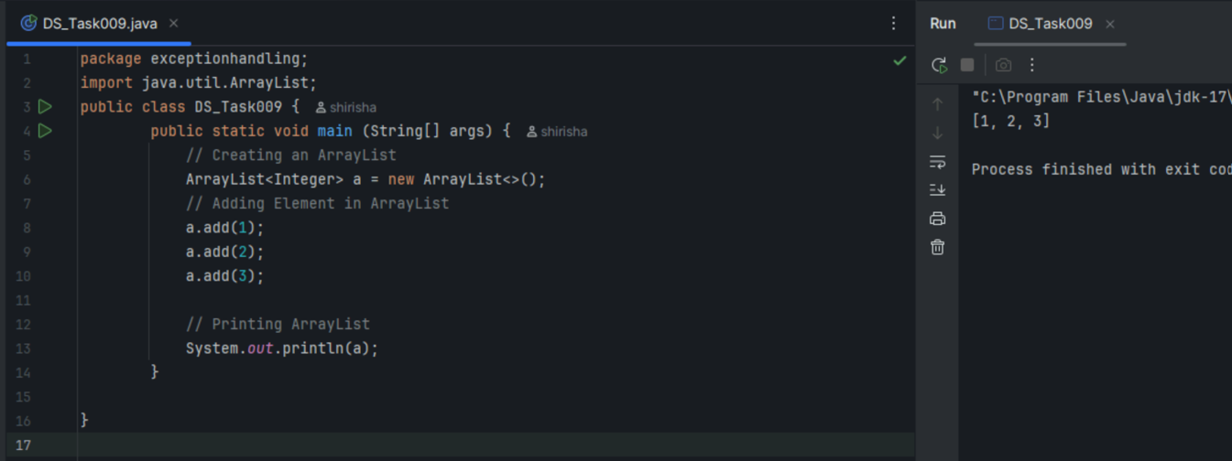

Task 10 – ArrayList Class methods

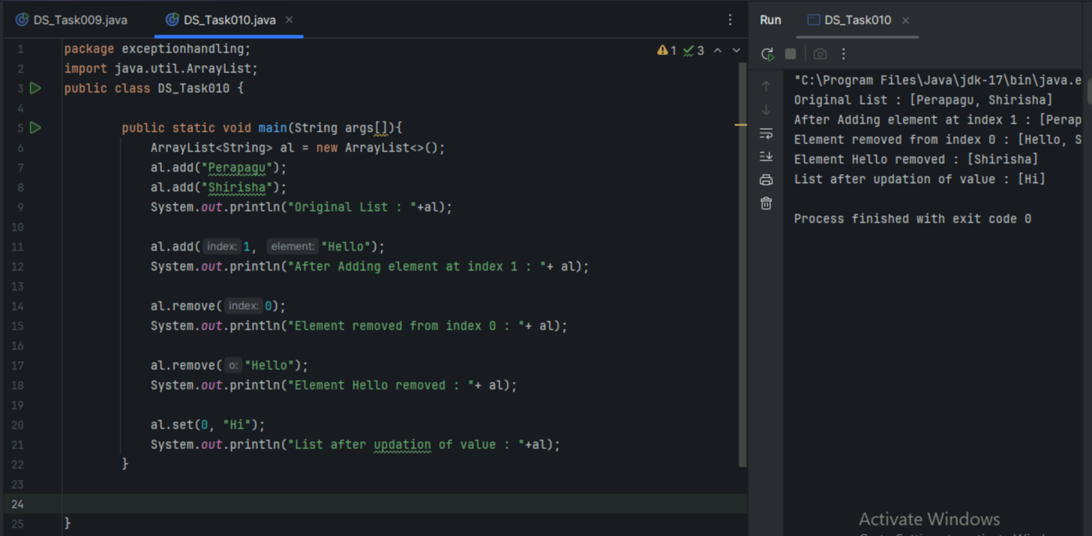

Task 11 what is the out put of the Inner Class program

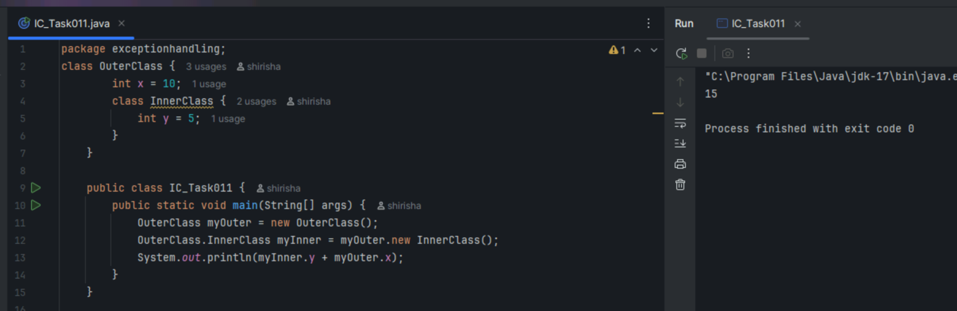

Task 12 - private inner class

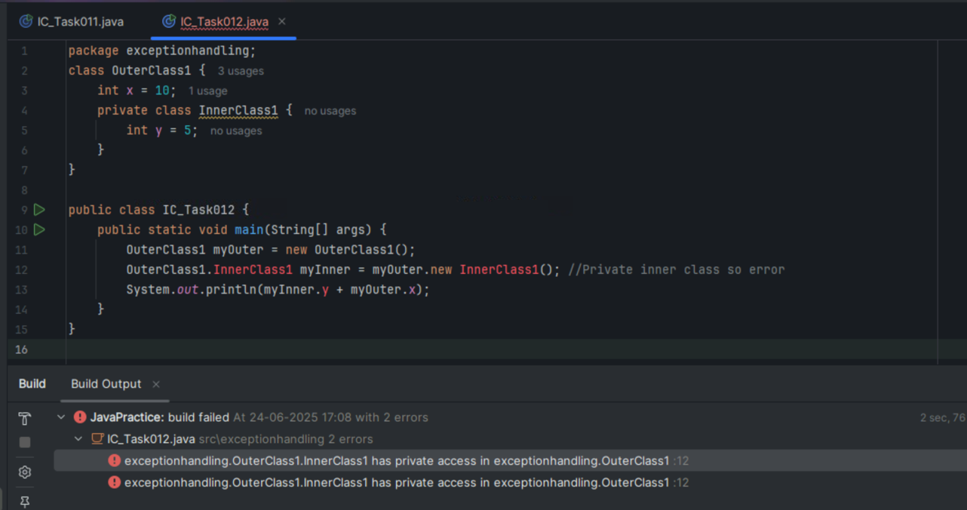

Task 13 - static inner class

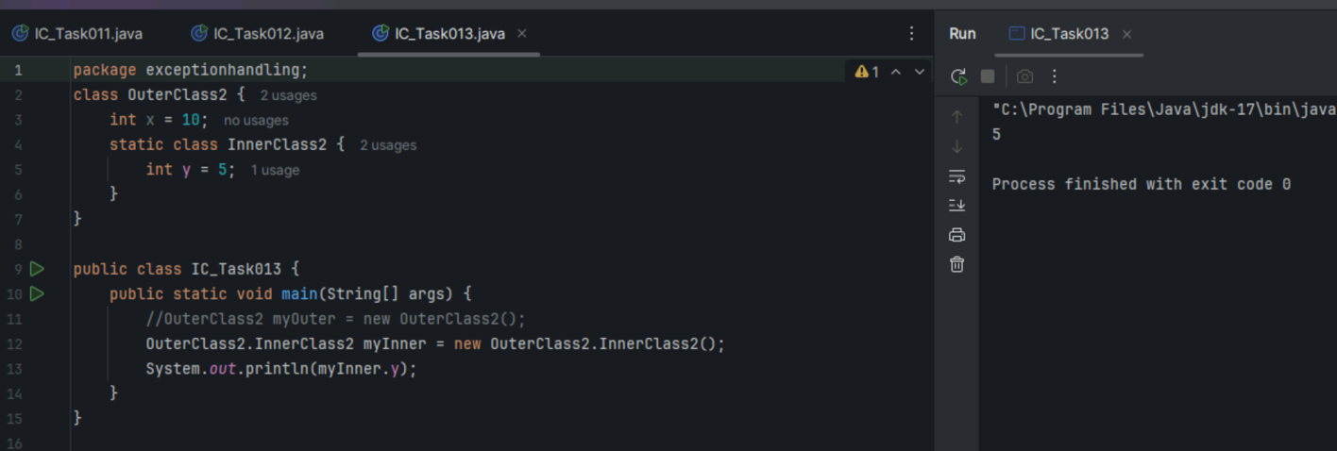

Task 14 – inner class method returning outer class variable

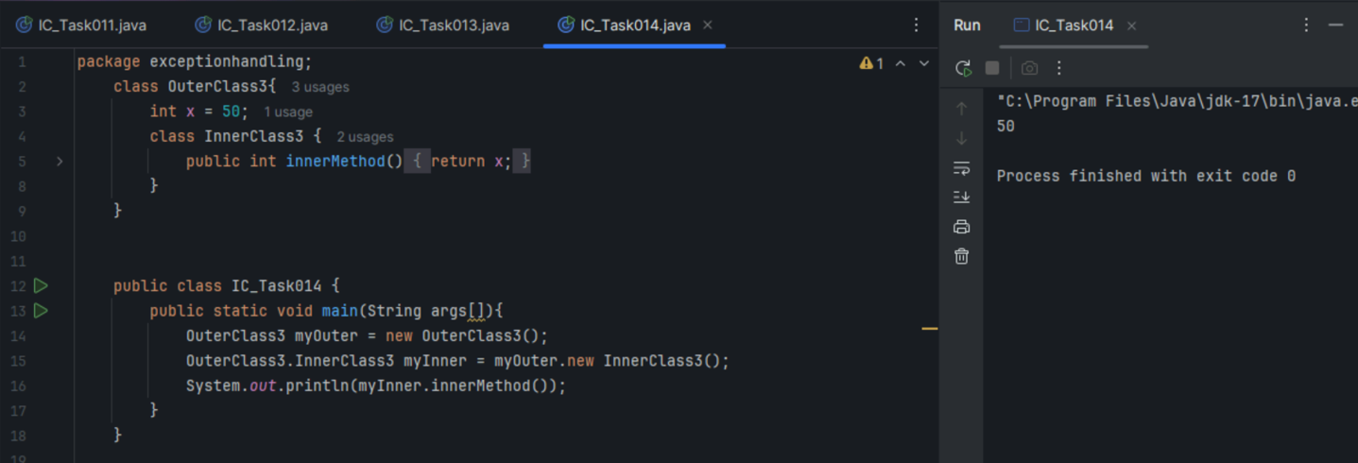

Task 15 – static inner class with static variable

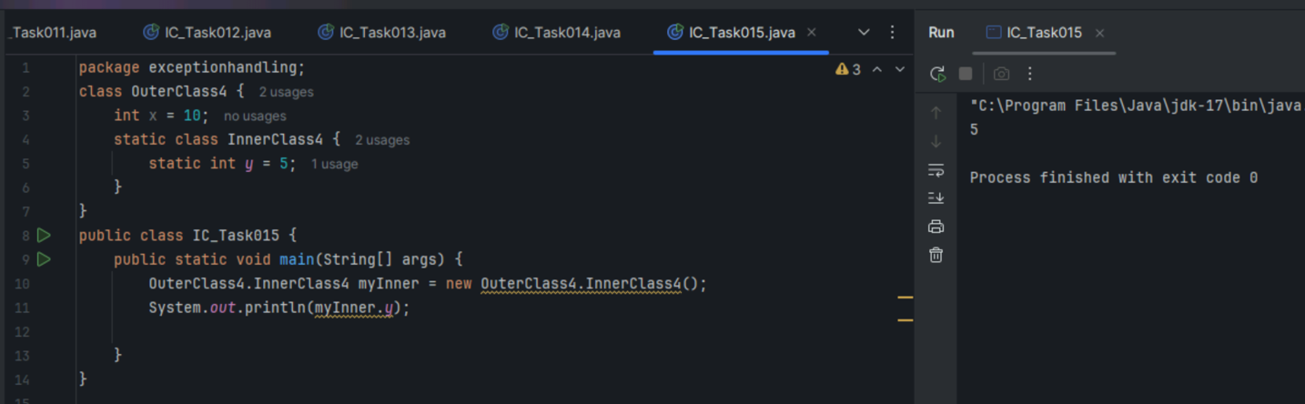

Task 17

Java 8 features

1. Lambda Expressions

pass functions/methods as data to make code shorter

1. Functional Interfaces

interfaces with only 1 abstract method used with lambda

1. Stream API

to process collections like lists in functional way

1. New Date and Time API

new date/time classes added more reliable ones

1. Collection API

ForEach() in Iterable to loop over collections in simple way using lamba, removeIf() in Collection etc.

1. Default and static methods in interface

allows interfaces to have method implementations

1. Method references

shortcut to refer methods using :: instead of full lambda

1. Java I/O improvements

like reading file line by line as a stream, new methods in Files class like walk(),find() and list().

Task 18 - Java8 ForEach example

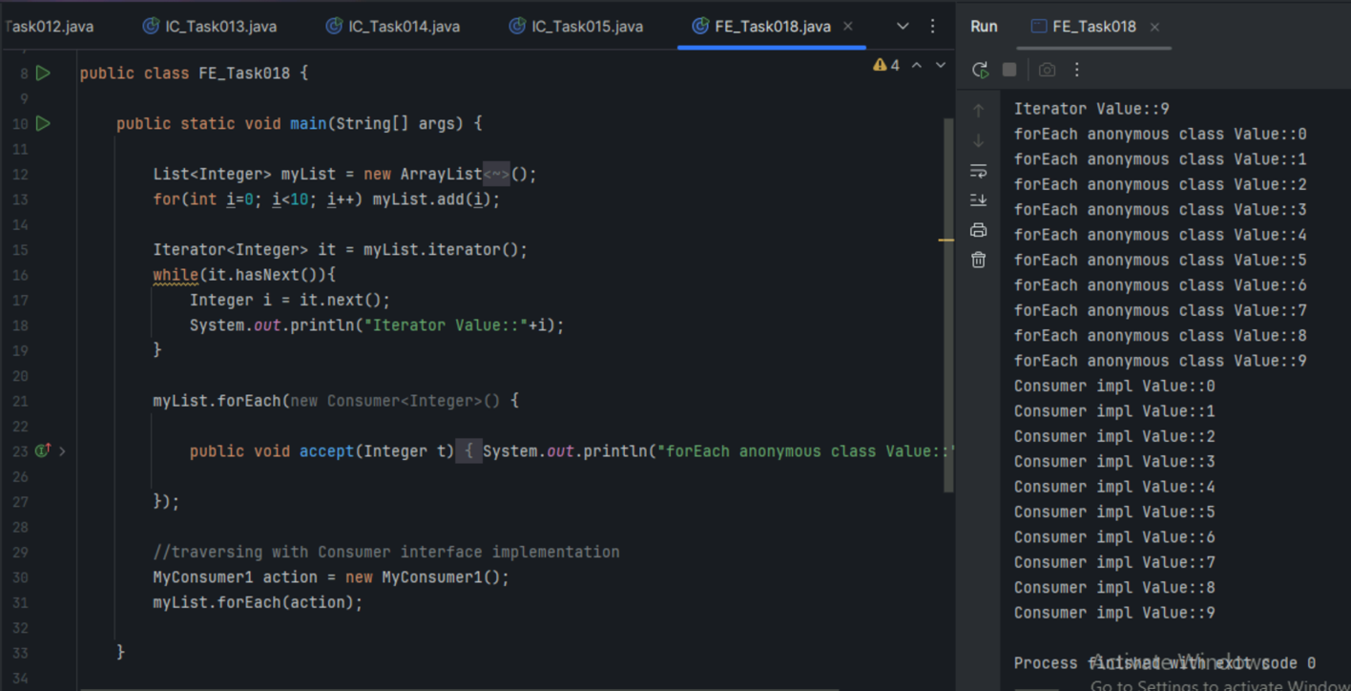

Task 20 – Collection Interfaces

